User Guide for GridFTP and RFT GUI
The GUI is a client of Globus GridFTP server 4.0(http://www.globus.org/toolkit/docs/4.0/data/gridftp/) and RFT service4.0(http://www.globus.org/toolkit/docs/4.0/data/rft/). It provides a friendly interface for users to transfer files(Client-Server transfer and third-party transfer are supported). The GUI is programmed in Java program language, so it supports multiple platforms, you can run it in Microsoft Windows, Linux or Mac.

Prerequirements:
- JDK 1.5.0+
- Globus Toolkit4.0.0+

Install
The GUI is distributed as a tar ball. You can download it from: (link). First, please untar it. In a Linux box, run the following command in command line:
tar xvzf gui.tar.gz
In Windows, you can do this through some software, such as WinRAR.

Startup the GUI
Change to the directory where your untared program lives, then run a script to startup the program. In Linux, please run:
./gui.sh
In Windows, please run:
gui.bat

If it is started up successfully, the program looks like Figure 1. There are three internal windows in the frame. The Local System window on the right side lists files on your local system. The Monitor Frame which is located at the upper left corner of the GUI can list all transfers, and the Message Frame displays some information related to transfers.
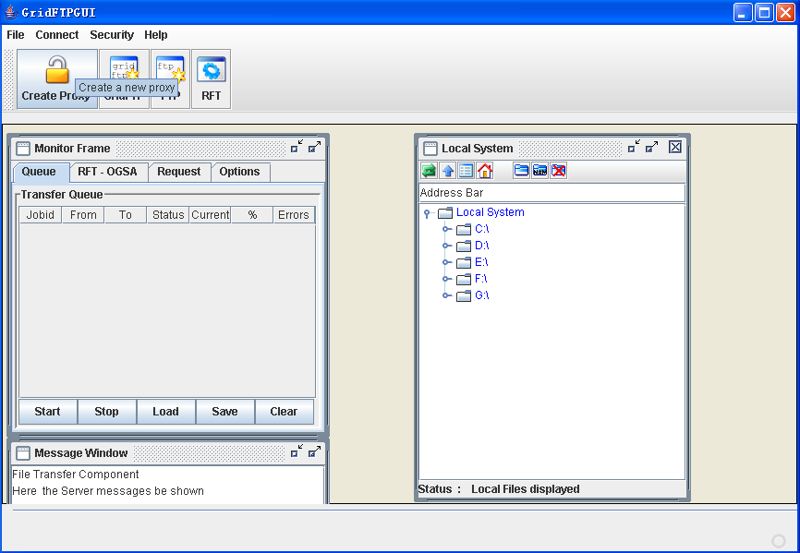
Figure 1 GridFTP & RFT GUI Client

Generate a Proxy certificate
You must generate a proxy certificate before file transmission. Click “Create Proxy” button on tool bar or Security->Create Grid Proxy in the menu, and input your private key pass phase in the popped up dialog(Figure 2). At last, click “Create” button to generate a proxy certificate. The Generation process will be failed if you don’t have a pair of X.509 certificate and private key. Please refer to related documentation for how to generate a certificate(http://www.globus.org/toolkit/docs/4.0/security/). 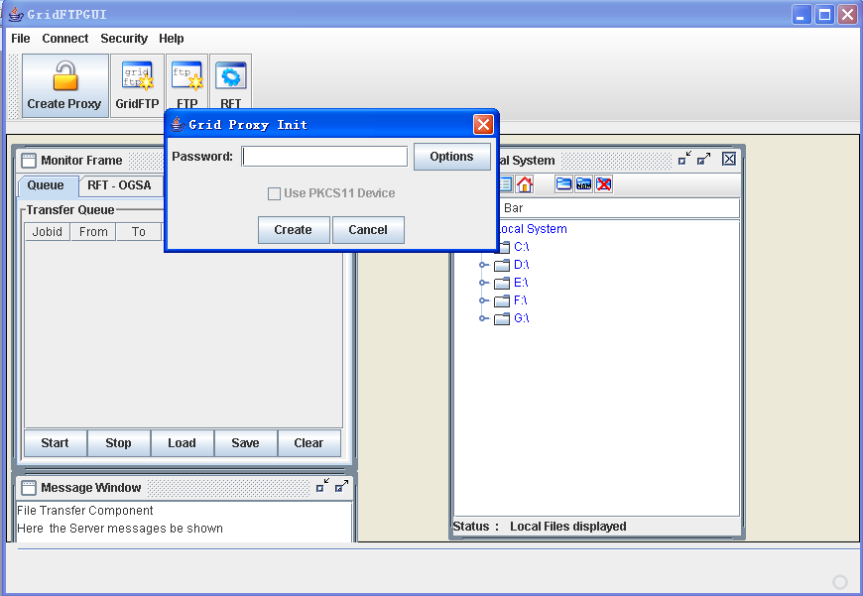
Figure 2 Input your private key pass phase

Transfer a file
By default, the program will list your local files when startup (in Windows, it lists all files of every partition; in Linux, it only lists your home directory). Please click “GridFTP” button in tool bar and input host name or IP address and port in the popped up dialog(Figure 3), then click OK. If connection is established successfully, files on remote GridFTP server will be listed. You can transfer a file or a directory drag and drop now. Third party transfer is also supported by opening multiple GridFTP server windows.
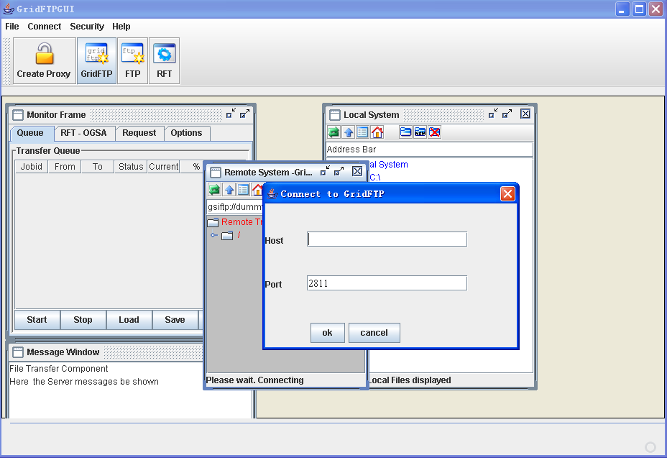.Figure 3 Connect to a GridFTP server

RFT client
To startup RFT service client, please click RFT button on the tool bar (Figure 4). There are two ways to transfer a file controlled by RFT. First, you can fill out all fields in “RFT Transfer Parameter” panel and click start button to start a transfer. Second, you can click “Load File” button to load a “.xfr” file from disk and transfer multiple files at the same time. Supplement 1 is a sample xfr file, you can write your own ones according to it. But fields in “RFT Options” panel should be filled no matter which way you choose. The transfer will be listed in the “Transfer Queue” panel. The items in the queue can be selected and right clicked to view information of this transfer or delete it from this table (Figure 5). Please refer to RFT documentation for explanations of the parameters.

Note:
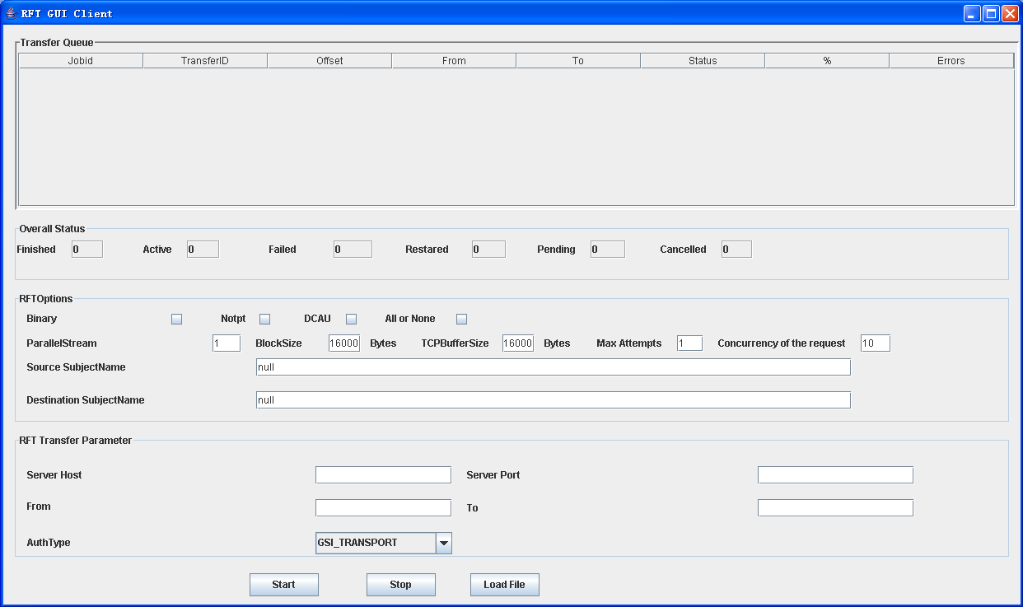
Figure 4 RFT Service client

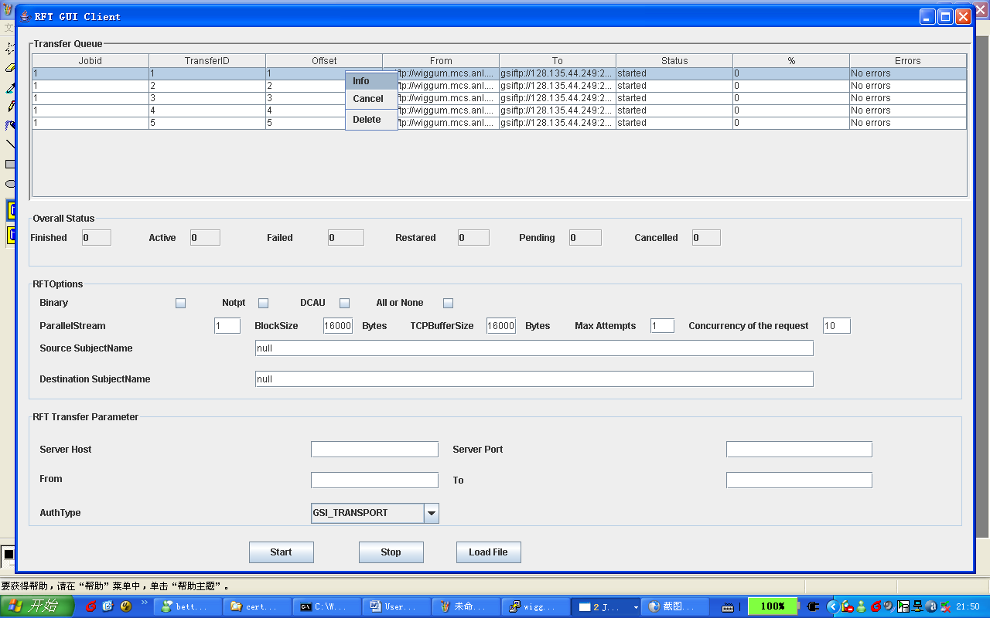
Figure5 Transfer Queue

Trouble shooting
If your GridFTP server is protected by a firewall, please set GLOBUS_TCP_PORT_RANGE environment variable, or the client maybe blocked by your firewall when it try to establish a data connection with the server.

Proxy certificate is usually short lived in consideration of security, its lifetime is usually 12 hours or 24 hours, so please renew your proxy certificate on time for fear of connection rejection by GridFTP server.

Also, you can probably refer to trouble shooting of RFT Service: http://www.globus.org/toolkit/docs/4.0/data/rft/admin-index.html#s-rft-admin-troubleshooting, and GridFTP: http://www.globus.org/toolkit/docs/4.0/data/gridftp/admin-index.html#s-gridftp-admin-troubleshooting.

If you have any other questions, please feel free to contact the developers: Liu Wantao liuwt@uchicago.edu or Ravi K Madduri madduri@mcs.anl.gov.

Supplement 1 A Sample .xfr file
true
16000
16000
false
1
true
1
/DC=org/DC=doegrids/OU=people/CN=Liu Wantao 209239
/DC=org/DC=doegrids/OU=people/CN=Liu Wantao 209239
false
10
gsiftp://wiggum.mcs.anl.gov:50002/homes/liuwt/rftTest.tmp
gsiftp://wiggum.mcs.anl.gov:50002/homes/liuwt/rftTest.tmp1

